Brian Wang

3/19/2023

Project 3

Part A: Diffusing Autoregulatory Gene

1. Implement a Finite Difference/Forward Euler approach to integrating this system to determine the concentration of both RNA and protein over space and time. Use a time step of 0.01 s, a total time of 30 s, a distance step of 0.02 µm and a total distance of 3.0 µm. For initial conditions, set the concentration of both RNA and protein to 0.5 mM everywhere in space. Plot the concentration of both protein and RNA at the first three positions in space as functions of concentration versus time. Also plot the concentration of both protein and RNA versus distance at both the first and last points in time.

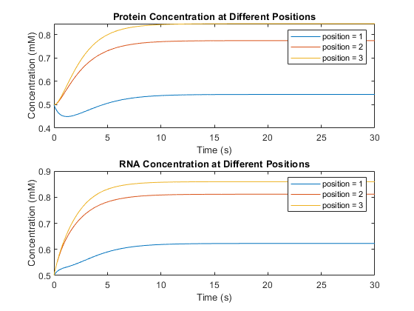

**PartA1a** substrate concentrations at different positions in the model. The first position has a lower concentration value than its neighbors due to diffusion effects decreasing the concentration of the substrates present. Changing the boundary conditions will cause different effects for the first position.

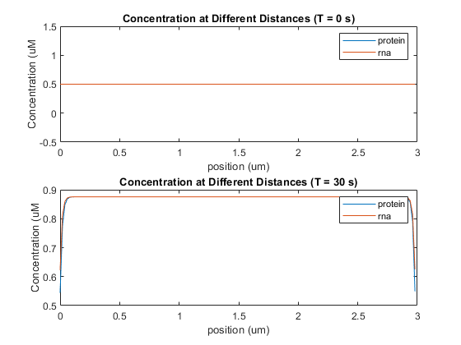

**PartA1b** substrate concentration at different points in time throughout the length of the model. The boundary condition used in this mode cause the substrate concentration to drop off at the ends of the model.

1. Repeat the simulation from (a), but this time set the initial concentration of both RNA and protein to 0.5 mM only in the first position in space, with the initial concentrations zero everywhere else.

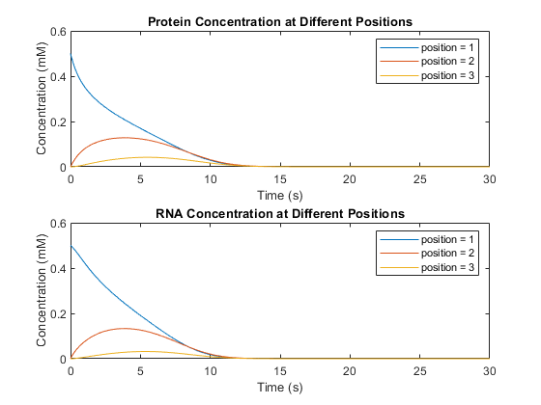

**PartA2a** Change in substrate concentration when initial concentrations are only present at the first position. The amount present was not sufficient to ensure the system was self-sustaining.

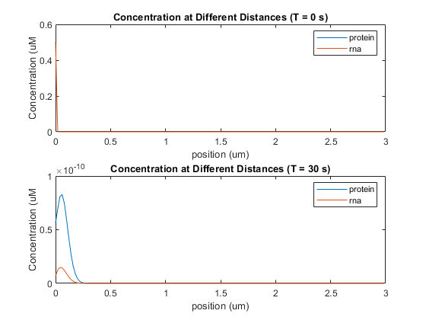

**PartA2b** substrate concentration at different points in time throughout the length of the model. The overall concentration at the end of the simulation was significantly smaller than the concentration at the beginning. A few orders of magnitude in fact.

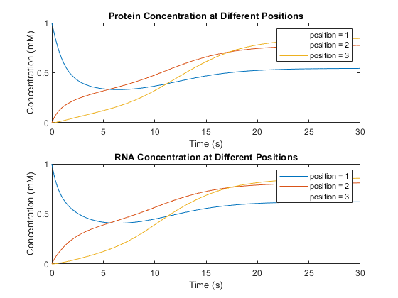

**PartA3b** Change in substrate concentration when initial concentrations are only present at the first position with . Unlike the previous example, the quantity here was sufficient for self-sustaining auto-activation.

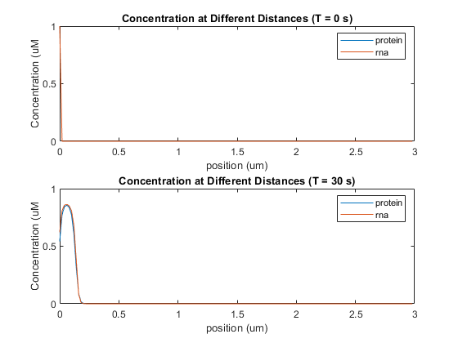

**PartA3b** Change in substrate concentration along the length of the model at select points in time. This time the concentration reaches its maximum a little bit away from the boundary. This is likely due to the effect of the diffusion term decreasing the concentration at the boundary.

1. Repeat the simulation from (c), but with the total time set to 50, 100 and 200 and 400 s.

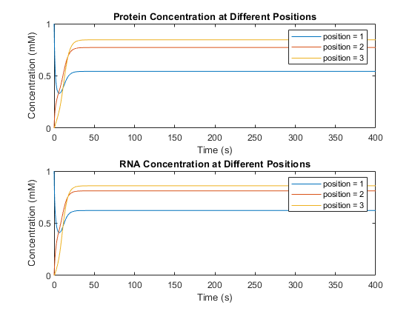

**Part4a** Due to the deterministic nature of this model. the substrate concentration at times 30, 50, 100, 200, and 400 can be determined using the 400 second simulation through looking up the values at the specified time. This is done in order to reduce space usage.

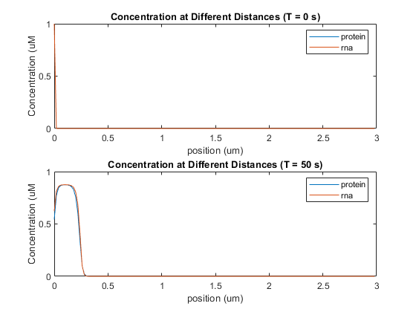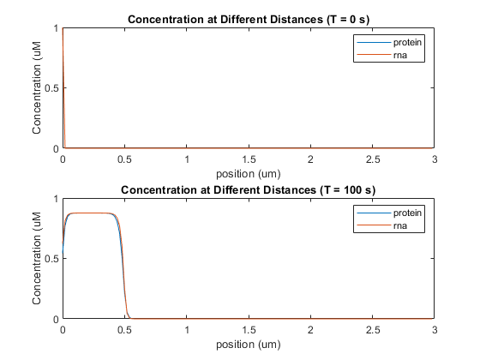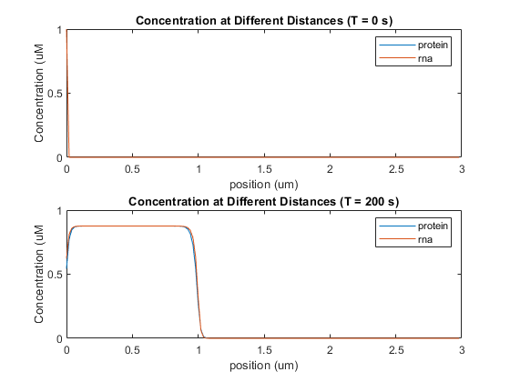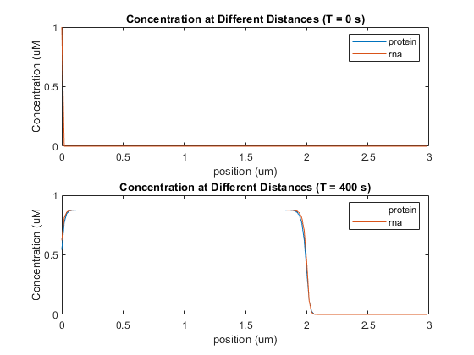

**Part4a-d-2** the diffusion of the substrate causes the genetic material to slowly expand across the model.

1. Write a paragraph explaining your observations, and how they are related to the steady states of the ODE-based system studied in Project 1.

It is found that this model through pre-emptive analysis that it is a deterministic model dependent on the initial conditions set for the simulation. In general, it seems like the boundary conditions for this model will cause the concentrations near the boundary to be less compared to its neighbors. The cause of this is likely due to the diffusion term decreasing the rate of change in substrate concentrations for both of these substances. When running the simulation for extended periods of time, the area where there is substrate present extends to the right at a rate of 0.005 um/s

Part B: A Diffusing Pair of Mutually-Inhibiting Genes.

1. Modify your model from Part A to represent this system. Once again, use a time step of 0.01 s, a distance step of 0.02 µm and a total distance of 3.0 µm.

Refer to the appendix for code changes.

1. Simulate the system for a total time of 5 seconds, with the following initial conditions: At the first position in space, set the initial concentration of both protein and RNA for gene X to 1.0 mM, while setting the initial concentrations for gene Y to zero; at the last position in space, set the initial concentration of both protein and RNA for gene Y to 1.0 mM, while setting the initial concentrations for gene X to zero; for all other points, set the initial concentrations of all species to zero. Plot the protein and RNA concentrations of both X and Y versus time at the first, last and middle points in space. Also plot the protein and RNA concentrations versus distance at both the first, last and middle points in time.

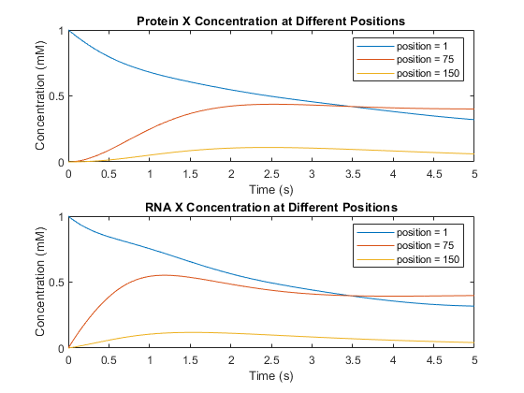

**PartB2a** Protein concentration of gene X at different locations. The concentration is the highest in the beginning where the initial conditions set it to 1. Although position 1 has the highest initial concentration it drops off at the end due to diffusion mechanics.

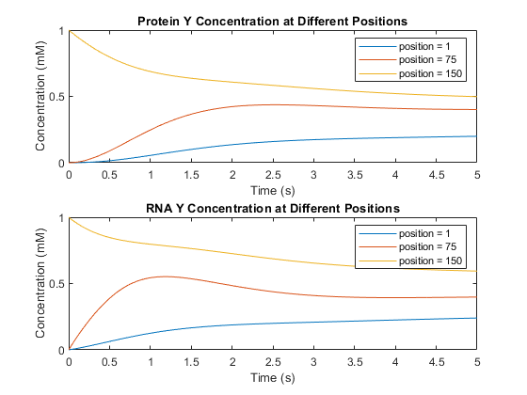

**PartB2b** Change in protein concentration over time at different positions. Unlike the previous graph, the protein concentration is greatest at the last position compared to the first position.

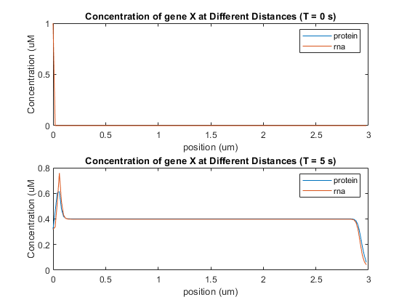

**PartB2c** Given enough time the proteins X and rna X were able to diffuse across the model. there was a sharp drop at the end due to the presence of gene Y and diffusion forces.

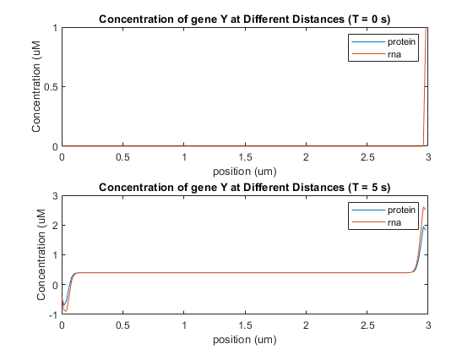

**PartB2d** an opposite effect can be seen with gene Y where it is concentrated at the end of the model and dilute at the beginning.

1. Repeat the simulation from (b), but with the total time set to 50, 100 and 200 and 400 s.

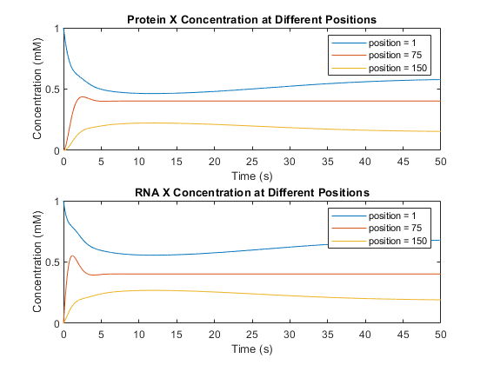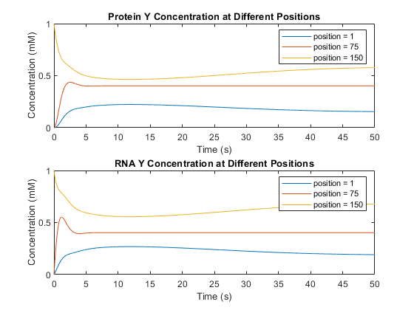

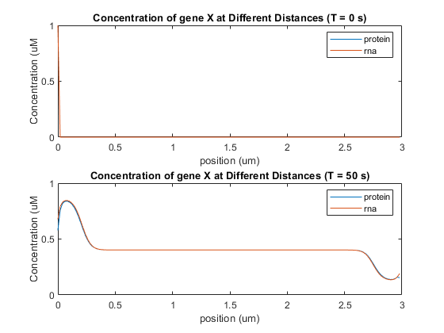

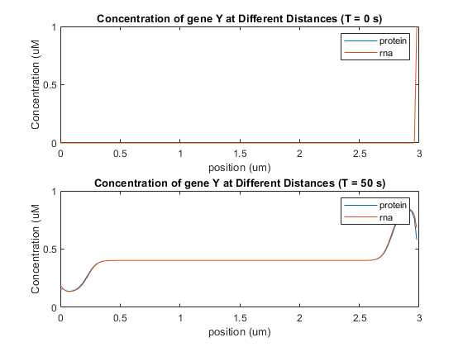

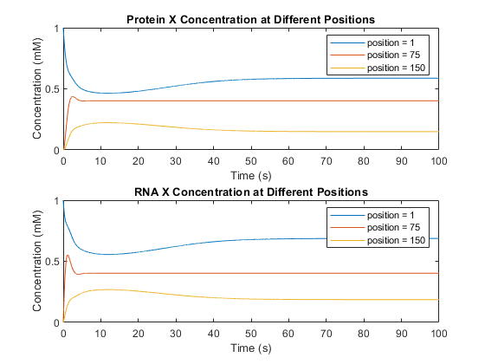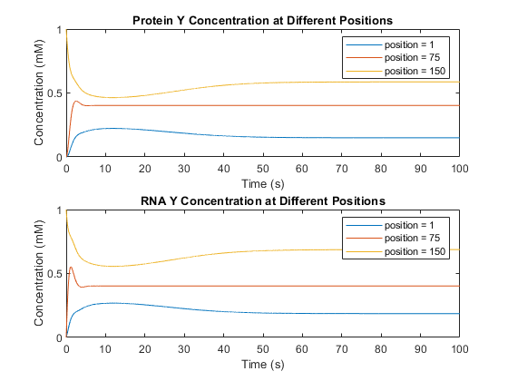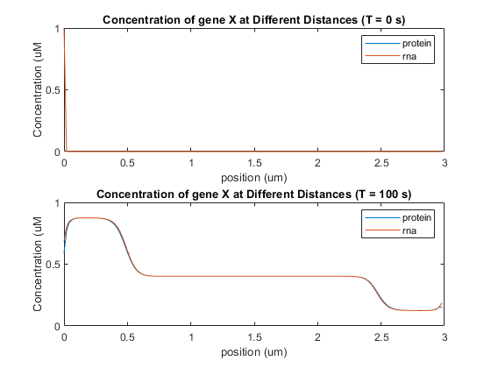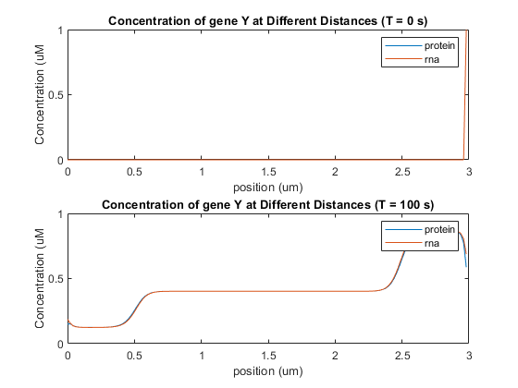

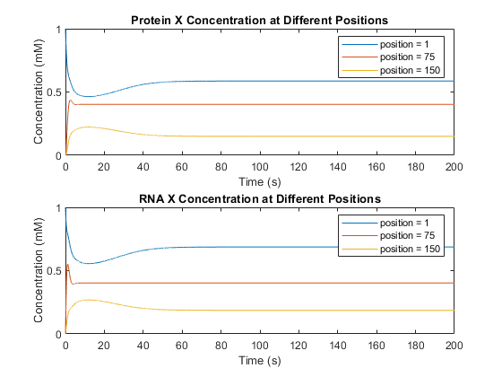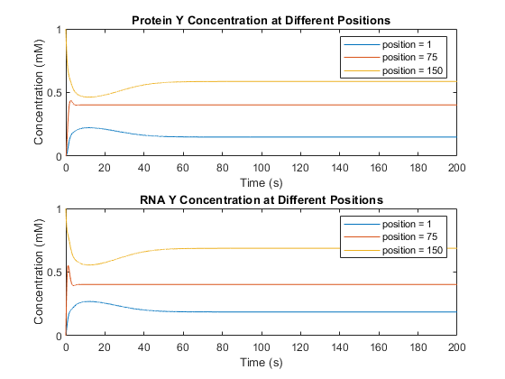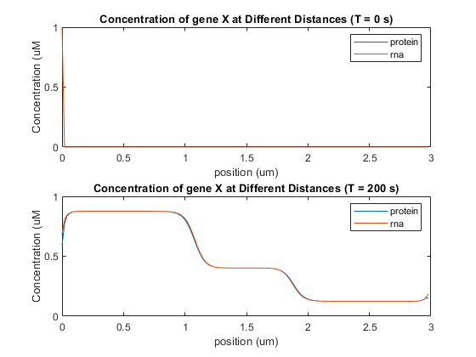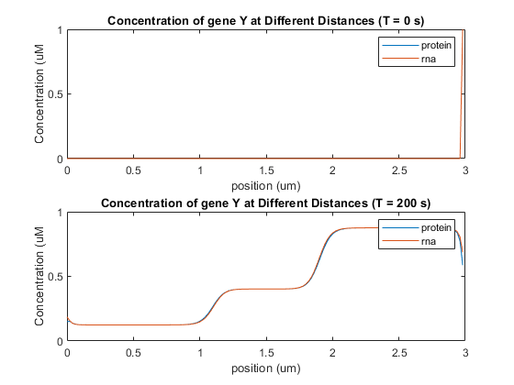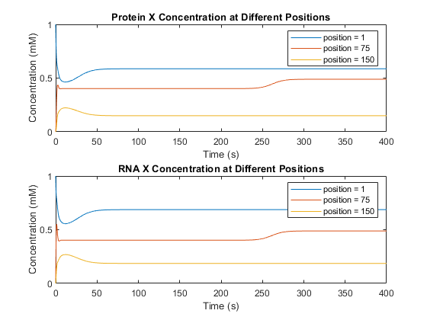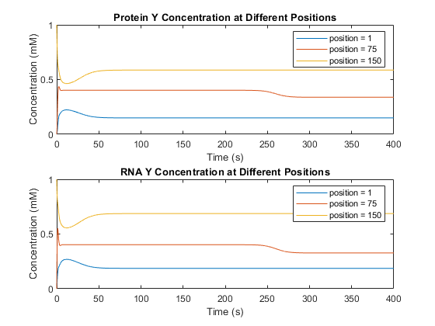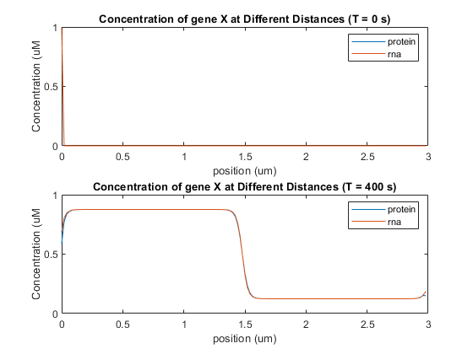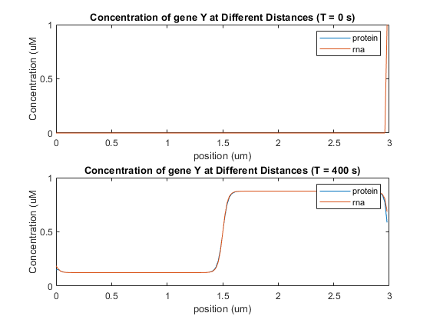

1. Repeat (c) with a different set of initial conditions: At both the first and last positions in space, set the initial concentration of both protein and RNA for gene X to 1.0 mM, while setting the initial concentrations for gene Y to zero; at the central position in space, set the initial concentration of both protein and RNA for gene Y to 1.0 mM, while setting the initial concentrations for gene X to zero; for all other points, set the initial concentrations of all species to zero.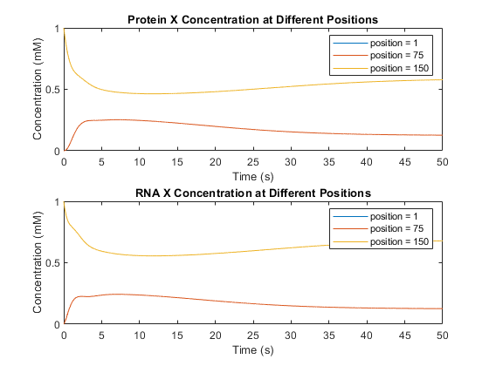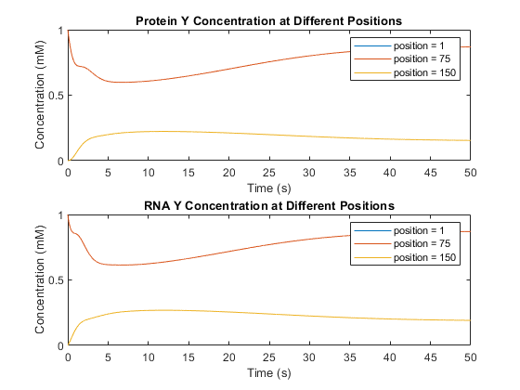

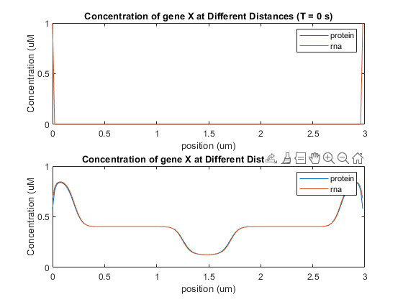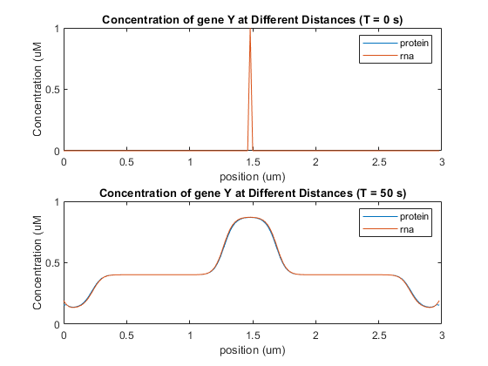

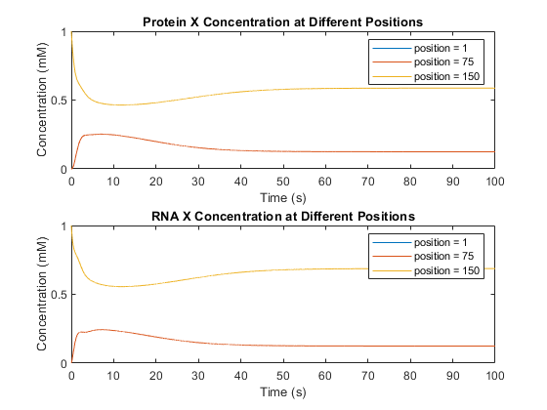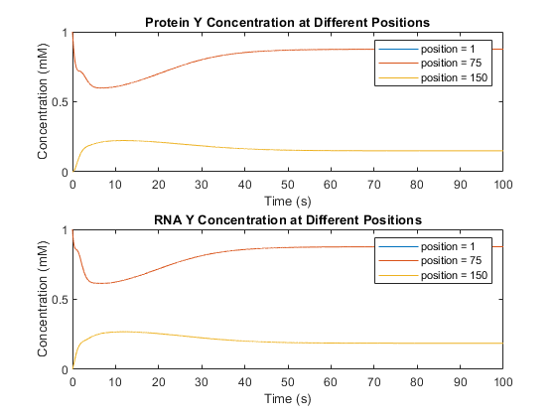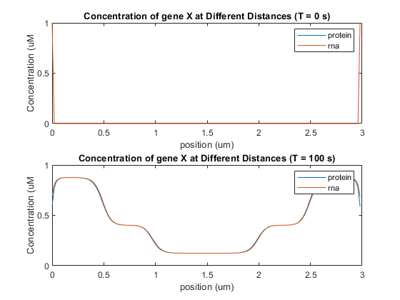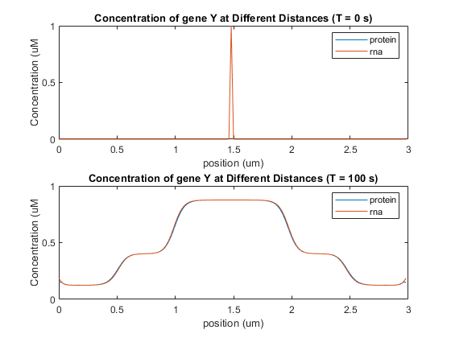

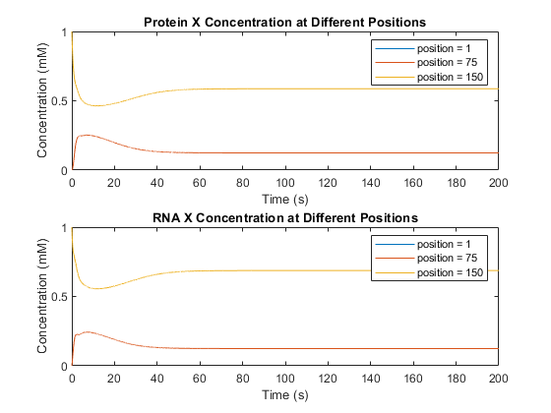

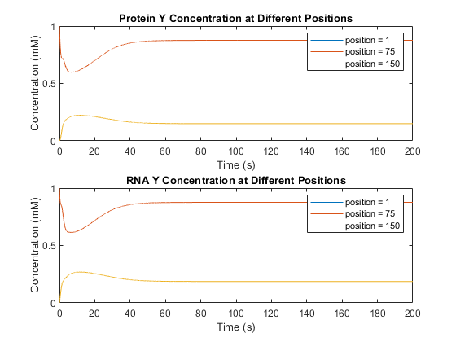

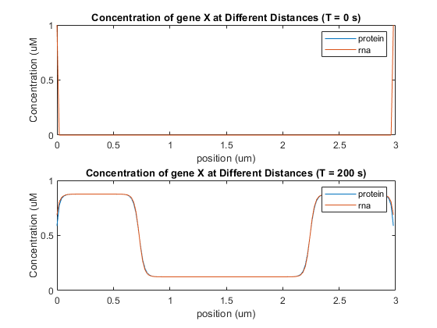

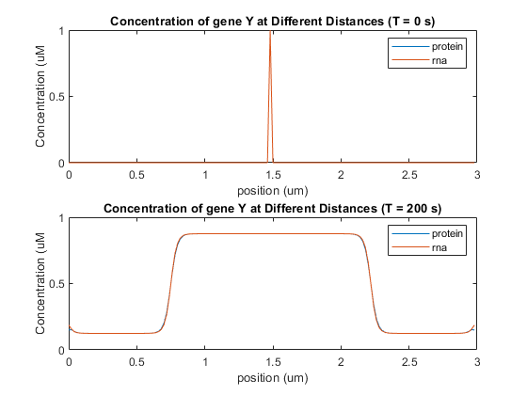

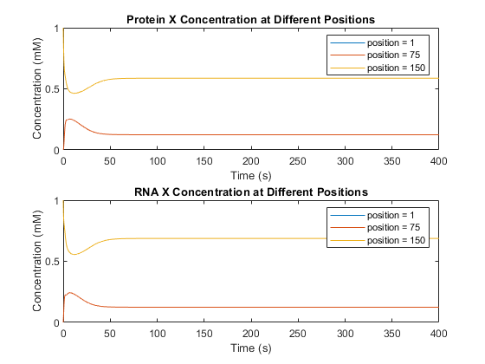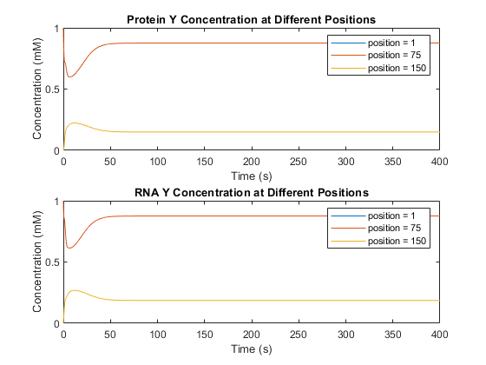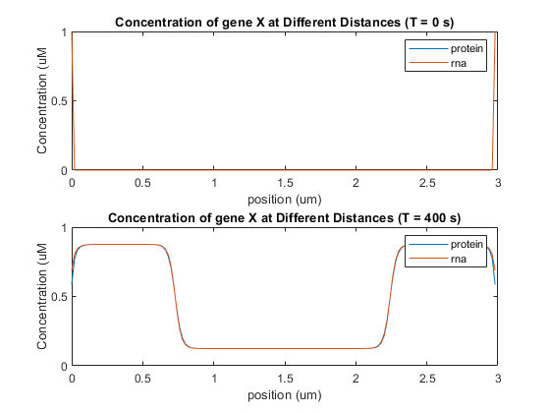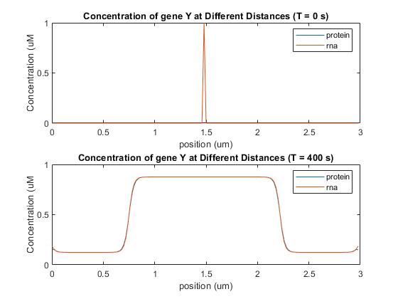

1. Write a paragraph explaining your observations.

The two proteins will typically spread out in both direction until they either reach a boundary or the opposing protein. In the case of the substrate reaching the boundary, the concentration will drop off as it reaches the boundary. In the case of the substrate reaching the opposing substrate, it will stop spreading.

Appendix: Part A MATLAB Code

mu = 1;

cprot = 1;

dprot = 0.0001;

omega = 1;

crna = 1;

drna = 0.0001;

totalTime = 200;

timeStep = 0.01;

time = 0:timeStep:totalTime;

totalDistance = 3.0;

distanceStep = 0.02;

position = 0:distanceStep:totalDistance - distanceStep;

khalf = 0.33;

Nx = ceil( (totalDistance - 0) / distanceStep );

Nt = ceil( (totalTime - 0) / timeStep );

%(concentration, time)

prot = zeros(Nx, Nt);

rna = zeros(Nx, Nt);

%initial conditions

rna(1, 1) = 1.0;

prot(1, 1) = 1.0;

%simulation here

for t = 1:Nt

for x = 1:Nx

rate_rna = (mu * prot(x, t)^2)/(khalf^2 + prot(x, t)^2);

rna_decay = -crna * rna(x, t);

rate_prot = omega * rna(x, t);

prot_decay = -cprot * prot(x, t);

del2Crna = -2 * rna(x, t);

del2Cprot = -2 * prot(x, t);

if x == 1

del2Crna = del2Crna + rna(x + 1, t);

del2Cprot = del2Cprot + prot(x + 1, t);

elseif x == Nx

del2Crna = del2Crna + rna(x - 1, t);

del2Cprot = del2Cprot + prot(x - 1, t);

else

del2Crna = del2Crna + rna(x - 1, t) + rna(x + 1, t);

del2Cprot = del2Cprot + prot(x - 1, t) + prot(x + 1, t);

end

del2Crna = del2Crna / distanceStep^2;

del2Cprot = del2Cprot / distanceStep^2;

dprotdt = rate_prot + prot_decay + (del2Cprot * dprot);

drnadt = rate_rna + rna_decay + (del2Crna * drna);

prot(x, t + 1) = prot(x, t) + dprotdt * timeStep;

rna(x, t + 1) = rna(x, t) + drnadt * timeStep;

end

end

figure(1);

subplot(2,1,1);

plot(time, prot(1, :), displayname='position = 1');

hold on

plot(time, prot(2, :), displayname='position = 2');

plot(time, prot(3, :), displayname='position = 3');

title('Protein Concentration at Different Positions')

xlabel('Time (s)')

ylabel('Concentration (mM)')

legend

hold off

subplot(2,1,2);

plot(time, rna(1, :), displayname='position = 1');

hold on

plot(time, rna(2, :), displayname='position = 2');

plot(time, rna(3, :), displayname='position = 3');

title('RNA Concentration at Different Positions');

xlabel('Time (s)');

ylabel('Concentration (mM)');

legend

hold off

figure(2);

subplot(2,1,1);

plot(position, prot(:,1), DisplayName='protein');

hold on

plot(position, rna(:,1), DisplayName='rna');

title('Concentration at Different Distances (T = 0 s)');

xlabel('position (um)');

ylabel('Concentration (uM')

legend

hold off

subplot(2,1,2);

plot(position, prot(:,ceil(totalTime / timeStep)), DisplayName='protein');

hold on

plot(position, rna(:,ceil(totalTime / timeStep)), DisplayName='rna');

title('Concentration at Different Distances (T = 200 s)');

xlabel('position (um)');

ylabel('Concentration (uM')

legend

hold off

Appendix: Part B MATLAB Code

mu = 1;

cprot = 1;

dprot = 0.0001;

omega = 1;

crna = 1;

drna = 0.0001;

totalTime = 400;

timeStep = 0.01;

time = 0:timeStep:totalTime;

totalDistance = 3.0;

distanceStep = 0.02;

position = 0:distanceStep:totalDistance - distanceStep;

khalf = 0.33;

Nx = ceil( (totalDistance - 0) / distanceStep );

Nt = ceil( (totalTime - 0) / timeStep );

%(concentration, time)

protx = zeros(Nx, Nt);

rnax = zeros(Nx, Nt);

proty = zeros(Nx, Nt);

rnay = zeros(Nx, Nt);

%initial conditions

rnax(1, 1) = 1.0;

protx(1, 1) = 1.0;

rnax(150, 1) = 1.0;

protx(150, 1) = 1.0;

rnay(75, 1) = 1.0;

proty(75, 1) = 1.0;

%simulation here

for t = 1:Nt

for x = 1:Nx

rnax_growth = mu * (1 - ((proty(x, t)^2)/(khalf^2 + proty(x, t)^2)));

rnax_decay = -crna * rnax(x, t);

protx_growth = omega * rnax(x, t);

protx_decay = -cprot * protx(x, t);

rnay_growth = mu * (1 - ((protx(x, t)^2)/(khalf^2 + protx(x, t)^2)));

rnay_decay = -crna * rnay(x, t);

proty_growth = omega * rnay(x, t);

proty_decay = -cprot * proty(x, t);

del2Crnax = -2 * rnax(x, t);

del2Cprotx = -2 * protx(x, t);

del2Crnay = -2 * rnay(x, t);

del2Cproty = -2 * proty(x, t);

if x == 1

del2Crnax = del2Crnax + rnax(x + 1, t);

del2Cprotx = del2Cprotx + protx(x + 1, t);

del2Crnay = del2Crnay + rnay(x + 1, t);

del2Cproty = del2Cproty + proty(x + 1, t);

elseif x == Nx

del2Crnax = del2Crnax + rnax(x - 1, t);

del2Cprotx = del2Cprotx + protx(x - 1, t);

del2Crnay = del2Crnay + rnay(x - 1, t);

del2Cproty = del2Cproty + proty(x - 1, t);

else

del2Crnax = del2Crnax + rnax(x - 1, t) + rnax(x + 1, t);

del2Cprotx = del2Cprotx + protx(x - 1, t) + protx(x + 1, t);

del2Crnay = del2Crnay + rnay(x - 1, t) + rnay(x + 1, t);

del2Cproty = del2Cproty + proty(x - 1, t) + proty(x + 1, t);

end

del2Crnax = del2Crnax / distanceStep^2;

del2Cprotx = del2Cprotx / distanceStep^2;

del2Crnay = del2Crnay / distanceStep^2;

del2Cproty = del2Cproty / distanceStep^2;

dprotxdt = protx_growth + protx_decay + (del2Cprotx * dprot);

drnaxdt = rnax_growth + rnax_decay + (del2Crnax * drna);

dprotydt = proty_growth + proty_decay + (del2Cproty * dprot);

drnaydt = rnay_growth + rnay_decay + (del2Crnay * drna);

protx(x, t + 1) = protx(x, t) + dprotxdt * timeStep;

rnax(x, t + 1) = rnax(x, t) + drnaxdt * timeStep;

proty(x, t + 1) = proty(x, t) + dprotydt * timeStep;

rnay(x, t + 1) = rnay(x, t) + drnaydt * timeStep;

end

end

figure(1);

subplot(2,1,1);

plot(time, protx(1, :), displayname='position = 1');

hold on

plot(time, protx(75, :), displayname='position = 75');

plot(time, protx(150, :), displayname='position = 150');

title('Protein X Concentration at Different Positions')

xlabel('Time (s)')

ylabel('Concentration (mM)')

legend

hold off

subplot(2,1,2);

plot(time, rnax(1, :), displayname='position = 1');

hold on

plot(time, rnax(75, :), displayname='position = 75');

plot(time, rnax(150, :), displayname='position = 150');

title('RNA X Concentration at Different Positions');

xlabel('Time (s)');

ylabel('Concentration (mM)');

legend

hold off

figure(2)

subplot(2,1,1);

plot(time, proty(1, :), displayname='position = 1');

hold on

plot(time, proty(75, :), displayname='position = 75');

plot(time, proty(150, :), displayname='position = 150');

title('Protein Y Concentration at Different Positions')

xlabel('Time (s)')

ylabel('Concentration (mM)')

legend

hold off

subplot(2,1,2);

plot(time, rnay(1, :), displayname='position = 1');

hold on

plot(time, rnay(75, :), displayname='position = 75');

plot(time, rnay(150, :), displayname='position = 150');

title('RNA Y Concentration at Different Positions');

xlabel('Time (s)');

ylabel('Concentration (mM)');

legend

hold off

figure(3);

subplot(2,1,1);

plot(position, protx(:,1), DisplayName='protein');

hold on

plot(position, rnax(:,1), DisplayName='rna');

title('Concentration of gene X at Different Distances (T = 0 s)');

xlabel('position (um)');

ylabel('Concentration (uM')

legend

hold off

subplot(2,1,2);

plot(position, protx(:,totalTime/timeStep), DisplayName='protein');

hold on

plot(position, rnax(:,totalTime/timeStep), DisplayName='rna');

title('Concentration of gene X at Different Distances (T = 400 s)');

xlabel('position (um)');

ylabel('Concentration (uM')

legend

hold off

figure(4);

subplot(2,1,1);

plot(position, proty(:,1), DisplayName='protein');

hold on

plot(position, rnay(:,1), DisplayName='rna');

title('Concentration of gene Y at Different Distances (T = 0 s)');

xlabel('position (um)');

ylabel('Concentration (uM')

legend

hold off

subplot(2,1,2);

plot(position, proty(:,totalTime/timeStep), DisplayName='protein');

hold on

plot(position, rnay(:,totalTime/timeStep), DisplayName='rna');

title('Concentration of gene Y at Different Distances (T = 400 s)');

xlabel('position (um)');

ylabel('Concentration (uM')

legend

hold off